**Testing & Integration Plan**

FH Mobile Application

Version 1.0

Prepared by

Omar Rivera Andrew Poirier Daven Amin Rick Rejeleene

Table of Contents

1.0 Introduction 3

2.0 Modular Test 3

2.1 User Platform Requirements 3

2.1.1 Bullet/Table 1 – Title of Test Case 3

2.2 Account Requirements 3

2.2.1 Bullet/Table 1 – Title of Test Case 3

2.3 Workout schedule requirements 4

2.3.1 Bullet/Table 1 – Title of Test Case 4

2.4 Validation Requirements 4

2.4.1 Bullet/Table 1 – Title of Test Case 4

2.5 Server Platform Requirements 4

2.5.1 Bullet/Table 1 – Title of Test Case 4

2.6 Server Requirements 5

2.6.1 Bullet/Table 1 – Title of Test Case 5

2.7 User Account Requirements 5

2.7.1 Bullet/Table 1 – Title of Test Case 5

2.8 User Interface Requirements 5

2.8.1 Bullet/Table 1 – Title of Test Case 5

2.9 Database Requirements 6

2.9.1 Bullet/Table 1 – Title of Test Case 6

2.10 Performance Requirements 6

2.10.1 Bullet/Table 1 – Title of Test Case 6

# 1.0 Introduction

This document describes the test plan and integration for the FH mobile application.

# 2.0 Modular Test

This section is broken down in to the different modular that will be tested in this section

## 2.1 User Platform Requirements

### 2.1.1 Test User Platform Requirements

### 

|  |  |
| --- | --- |
| Requirement Number | 3.2.1 |
| Requirement Name | User Platform Requirements |
| Requirement Description | The User platform is to be tested by using a device with an Android Operating System. |
| Pre conditions | The User needs a Device with an Android Operating System with Version 4.0 or higher.  The User also needs to have Intel XDK software. |
| Procedures | 1. Find an android device. 2. Verify that it is running Android version 4.0 or higher. 3. Connect the Device to the System. 4. Open Intel XDK 5. Install the application by clicking Build using Intel XDK. 6. Open the Application on your device named Intel XDK. |
| Post Conditions | * If the Application is successfully installed, it will open. * If the Application is not successfully installed, it will prompt the user “Application installation failed” |
| Test Results | Pass if all the Post Conditions are met. |

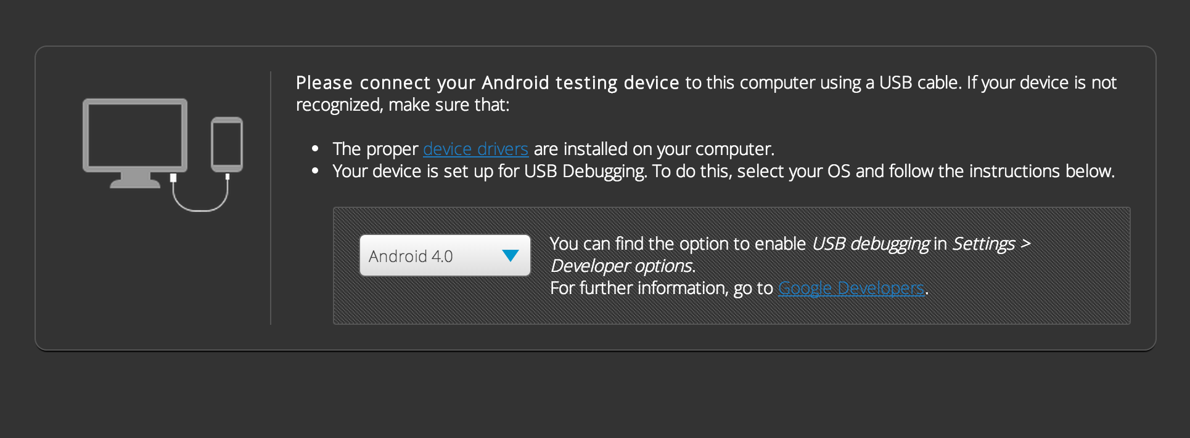 Figure for 2.1

## 

## 2.7 User Account Requirements

### 2.7.1 Test User Account Requirements - full name

|  |  |
| --- | --- |
| Requirement Number | 3.2.7 |
| Requirement Name | User Account Requirements – full name |
| Requirement Description | The User account contains a form that needs to have valid information for testing, here the first name and the last name is tested. |
| Pre conditions | The User needs to be in the User Information Page. |
| Procedures | 1. Enter the First Name. 2. Enter the Last Name. 3. Enter the valid information for the rest of the form. 4. Click Submit after entering the above information. |
| Post Conditions | * If the First name and Last name is empty, the user information page will not submit. * If the First name and Last name are alphabets, the page will successfully pass through. * If the First name and Last name contain numbers, the page will not submit. |
| Test Results | * Pass if all the Post Conditions are True. |

## 

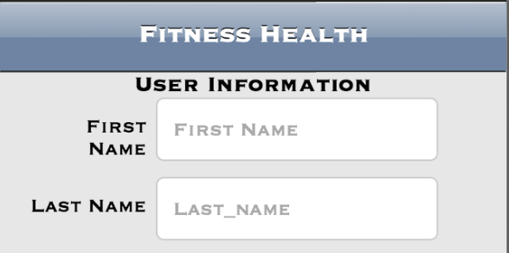

Figure 2.7.1

### 2.7.2 Test User Account Requirements - Login name

|  |  |
| --- | --- |
| Requirement Number | 3.2.7 |
| Requirement Name | User Account Requirements – Login name |
| Requirement Description | The User account form needs to be verified for testing, the login name is tested here. |
| Pre conditions | The User needs to be in the User Information Page. |
| Procedures | 1. Enter the Login ID 2. Enter the valid information for the rest of the form. 3. Click Submit after entering all the above Information |
| Post Conditions | * If the Login ID is empty, the user information page will not submit * If the Login ID is greater than 10 characters, the user information page will not submit. |
| Test Results | * Pass if all the Post conditions are True |

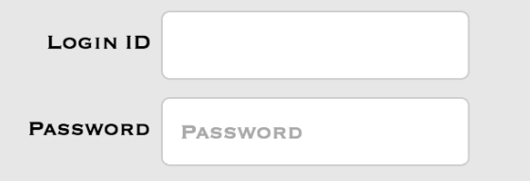

Figure for 2.7.2, 2.7.3

### 2.7.3 Test User Account Requirements - Password

|  |  |
| --- | --- |
| Requirement Number | 3.2.7 |
| Requirement Name | User Account Requirements – Password |
| Requirement Description | The User account form contains a password and the password field is tested here. |
| Pre conditions | The User needs to be in the User Information Page. |
| Procedures | 1. Enter the Password 2. Enter the valid information for the rest of the form. 3. Click Submit after entering all the above information. |
| Post Conditions | * The Page will not submit if the Password is empty * The Page will submit if the Password is not empty. |
| Test Results | * Pass if all the Post conditions are True |

### 2.7.4 Test User Account Requirements - Account Balance Information

|  |  |
| --- | --- |
| Requirement Number | 3.2.7 |
| Requirement Name | User Account Requirements – Balance Information |
| Requirement Description | The User account contains balance information for new user, the balance amount is set by default. |
| Pre conditions | The User needs to be in the User Information Page. |
| Procedures | 1. The User needs to fill valid information for the rest of the form. 2. Click Submit |
| Post Conditions | * The Default User balance is assigned for the user. |
| Test Results | * Pass if all the Post conditions are True |

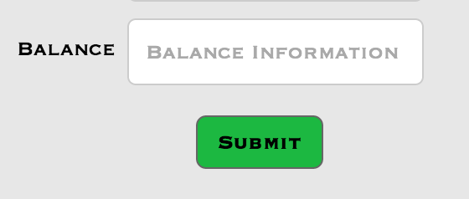

Figure for 2.7.4